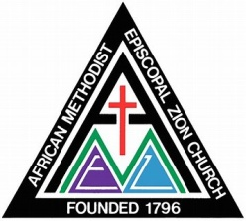
MT. Zion A.M.E. Zion Church

Information for Baptismal Record
(Please Print)

Date of Baptism:_______________________

Family Name:__________________________________________________________________

Infant/Child’s Full Name:__________________________________ Male:_____ Female: _____

Date of Birth: ___________________________ Place of Birth: __________________________

Father’s Full Name: _____________________________________________________________

Baptized: _____ Church: _________________________________________________________

Mother’s Full Name: ____________________________________________________________
(Including Maiden Name)
Baptized: _____ Church: _________________________________________________________

Home Address: _________________________________________________________________

Email: ________________________________ Phone Number: __________________________

Maternal Grandparents: __________________________________________________________

Paternal Grandparents: ___________________________________________________________

Godparents / Sponsors: __________________________________________________________

Other Information: _____________________________________________________________

_____________________________________________________________________________

………………………………………………………………………………………………………
(Office Use Only)

____ Certificate Prepared | ____ Pastor Copy
____ Published In bulletin | ____ Date / Church Calendar
____ Membership Record Posted | ____ Pastor Contact

